Task 2: Update JSON & Resolve Conflicts
- Create a new branch named _new (e.g., Tutedude_new).
- Update the content of the JSON file used for the /api route in this branch.
- Merge the _new branch into the main branch.
- If there are conflicts during the merge, resolve them by accepting the changes from the _new branch.
- Add the resolved changes to the staging area, commit them, and push the updates to the remote repository.

Created a new branch : using “git branch Tutedude_new”
listing the all branches using the git branch
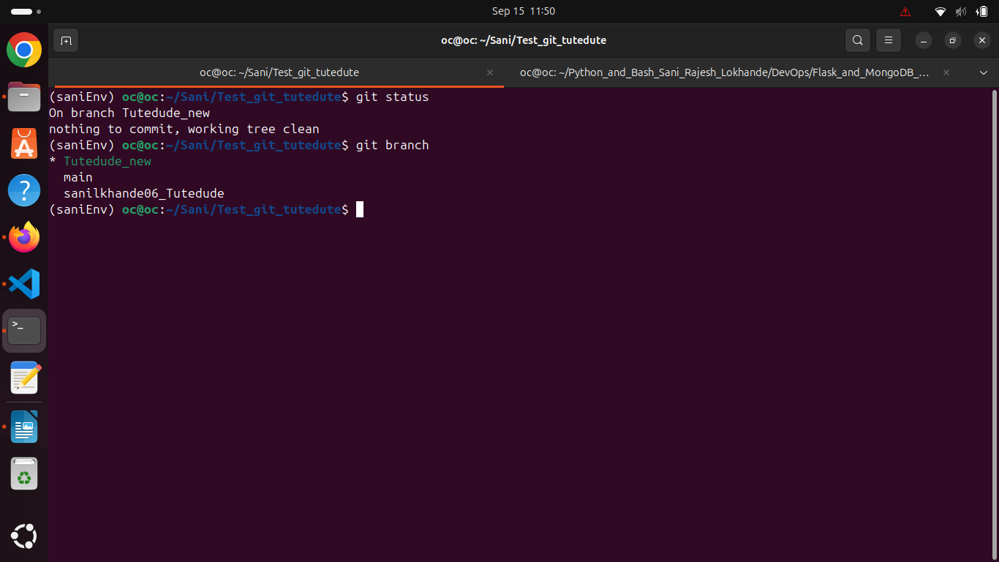
student_info.json file info changed : staged the changes and commited the changes using “git commit -m “message” and using the cat command printing the file values.
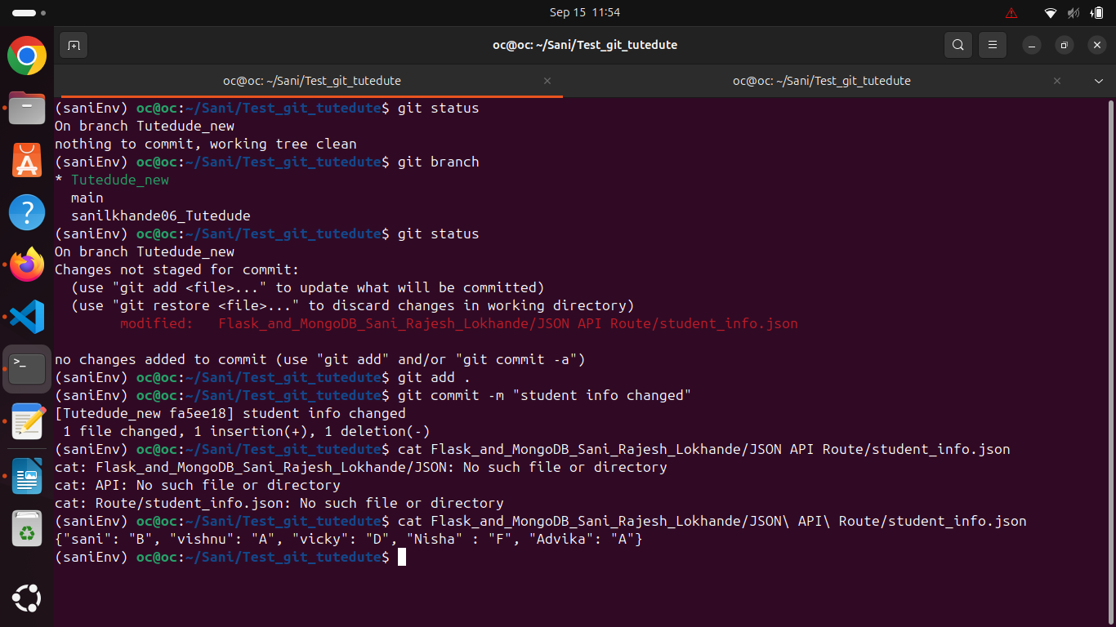
Resoling conflicts and commit the changes:
switched the branch to main branch using the “git checkout main” and merge the new branch using the git merge Tutedude_new
got the merge conflict because changes in main and Tutedude_new at the same lines.
To resolve the conflict accepted the changes from Tutedude_new using git checkout –theirs . : “.” is specifies the all changes
after merging committed the changes into main branch and printed the new changes using cat command.
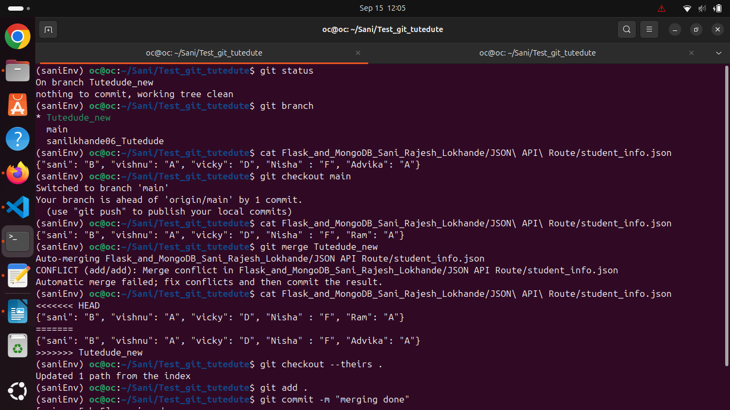
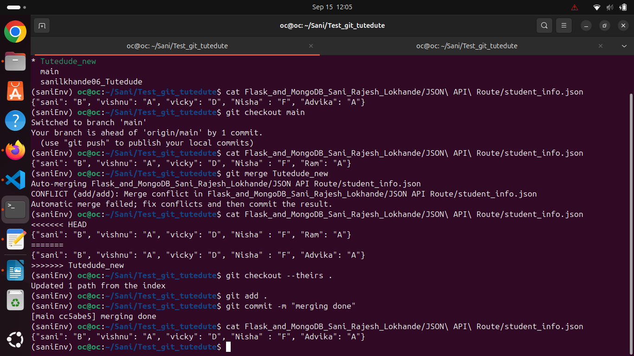
pushing to remote: after committing the changes pushed the changes to remote using git push remote path is already set and ssh keys also present so didn’t asked for password.
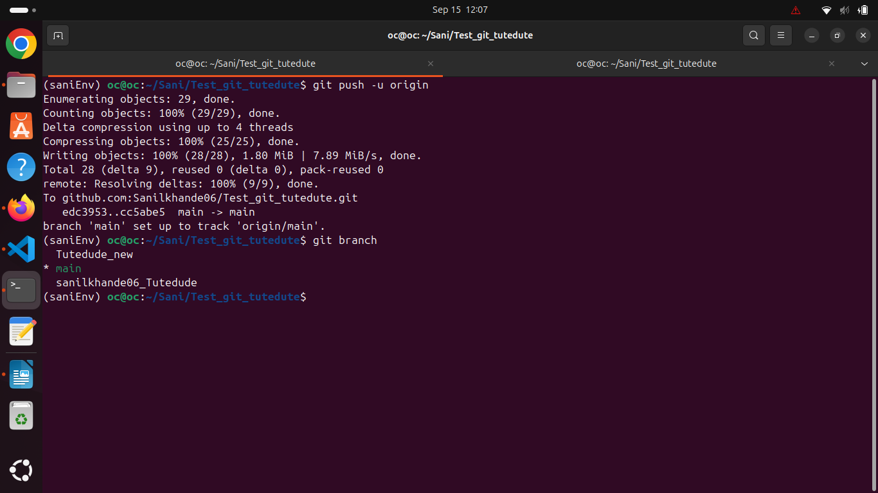
Merged it to remote :
